Jmeter Performance Testing Course Works

Contents

1. Week 1 Course Works: Jmeter Fundamentals, Install and Create A Basic Jmeter Test Plan 3

# Week 1 Course Works: Jmeter Fundamentals, Install and Create A Basic Jmeter Test Plan

* Create Jmeter WebsiteTest Plan (http://jmeter.apache.org) for 5 users, each user runs 2 times these test cases:
  + TC1: To measure Response Time when User goes to Download/Download Releases (<http://jmeter.apache.org/download_jmeter.cgi>). Add assertion to check for “Download Apache Jmeter” text in the response.
  + TC2: To measure Response Time when User goes to about/Overview (<http://jmeter.apache.org/index.html>). Add assertion to check for “open source software” text in the response.
  + TC3: To measure Response Time when User goes to Documentation/Get Started (<http://jmeter.apache.org/usermanual/get-started.html>). Add assertion to check for “Getting Started” text in the response.
  + TC4: To measure Response Time when User goes to Download/Release Notes (<http://jmeter.apache.org/usermanual/changes.html>). Add assertion to check for “Changes” text in the response.
  + Add View Results Tree

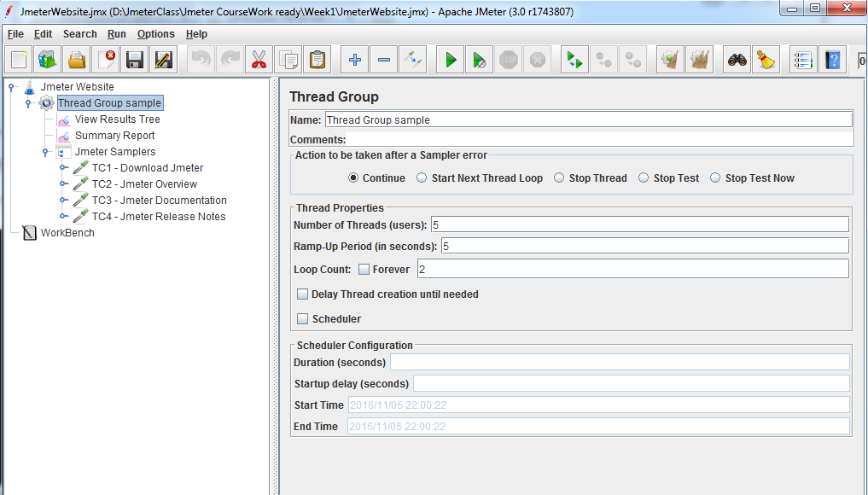

* Create blazemeter Website Test Plan (https://www.blazemeter.com) for 10 users, each user runs 1 times these test cases:
  + TC1: user goes to FEATURES. Add assertion to check for “JMeter performance testing” text in the response.
  + TC2: user goes to PRICING. Add assertion to check for “Try BlazeMeter for free now. Choose your plan later” text in the response.
  + TC3: user goes to RESOURCES. Add assertion to check for “Five Easy Steps for Switching from LoadRunner to Apache JMeter” text in the response.
  + TC4: user goes to BLOG. Add assertion to check for “Run massively scalable performance tests on web, mobile, and APIs” text in the response.
  + Add View Results Tree

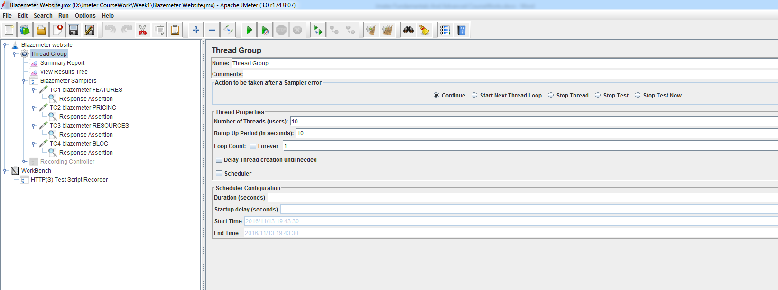

* install Notepad++ using 32bits Installer from <https://notepad-plus-plus.org/download/v7.2.html> ; install Plugin Manager from <https://sourceforge.net/projects/npppluginmgr/>
* Questions about Performance Test and Jmeter:

1. What is Load, Performance and Stress Test?
2. Why do we need to do Performance Testing?
3. What is Jmeter?
4. How Jmeter works?
5. Why use Jmeter?
6. What is Thread Group, Sampler, Assertion and Listener in Jmeter?